Assignment 2Face book link: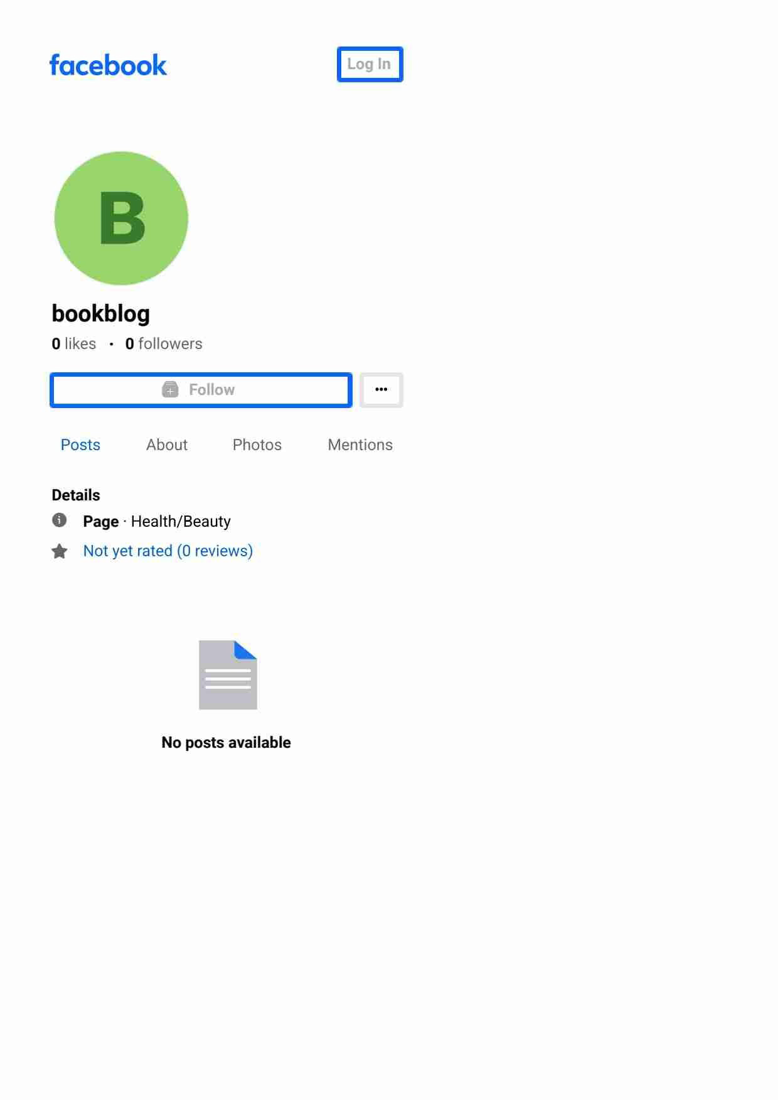https://www.facebook.com/profile.php?id=61551989546067&mibextid=ZbWKwL

